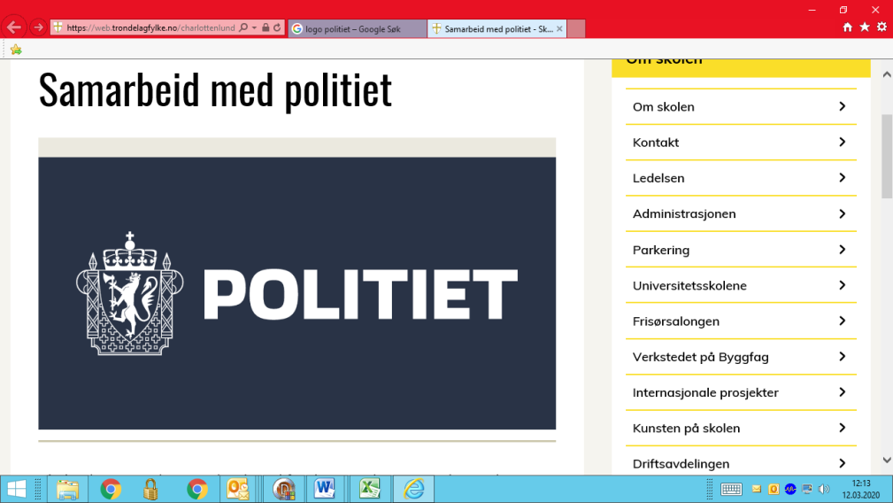

**TEMPORARY PRACTICE FOR DIGITAL APPLICATION SUBMISSION**

In connection with the police public services limited availability due to the risk of infection by Covid-19, the police, in collaboration with UDI, want to offer an alternative, digital solution for filing applications, without personal attendance. Digital submission of applications is based on the UDI's Guideline 2020-010, <https://www.udiregelverk.no/retributors/udi-retningslinjer/udi-2020-010/>

The scheme will only apply if you have chosen **Service Centre for Foreign Workers (SUA) in Oslo as your meeting point and completed an online application in the application portal.**

The scheme and the e-mail will be deleted as soon as the Police have created your case, in order to compile with the Data Protection Directive

Please fill out the form below and return it to the police. Please use the address: [oslo.fuf.sua@politiet.no](mailto:oslo.fuf.sua@politiet.no)

**All applicants must fill out this section**

|  |  |
| --- | --- |
| Application receipt number* |  |
| Are you temporarily, fully or partially laid of from work? |  |
| If yes, please specify dates |  |
| Are you applying with power of attorney? If yes, specify the name of the person you are giving power of attorney to |  |

*'This number can be found on the cover letter of your application. The number starts with "oslopd SUA-"

After you have completed the form above and returned it to the police, you will receive an automatic email from the police within a few working days with your DUF-number. Only after you have received the automatic email can you forward documents required for UDI here: <https://www.udi.no/en/word-definitions/forwarding-documents/>

Follow the checklist specific to your case: <https://www.udi.no/en/word-definitions/checklists-which-explains-which-documents-you-must-hand-in-with-your-application/>

If you receive a positive decision, you can book an appointment in the Application Portal for a residence card. Do not book appointments before you have received a decision.