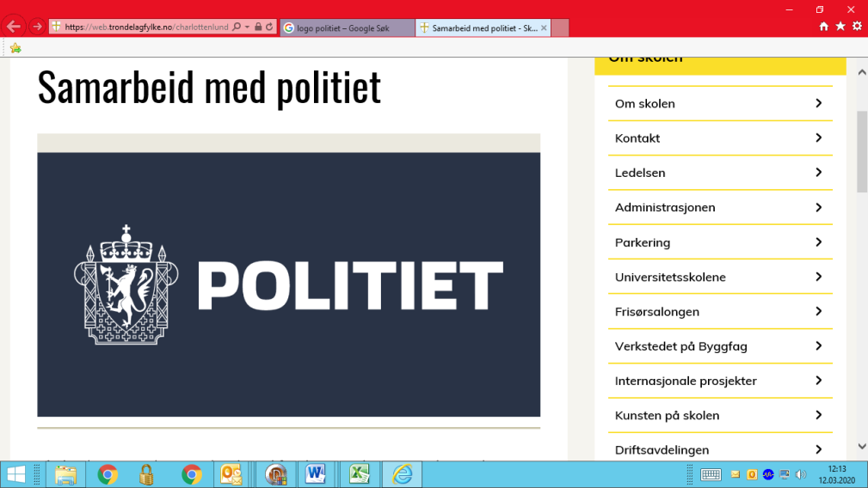

**Registration scheme for EU/EEA-nationals**

In connection with the police public services limited availability due to the risk of infection by Covid-19, the police, in collaboration with UDI, want to offer an alternative, digital solution for filing registrations, without personal attendance. This solution is based on the UDI's Guideline 2020-010, <https://www.udiregelverk.no/retributors/udi-retningslinjer/udi-2020-010/>

Please fill out the form below relevant to your case type and return it to the police. Please use the address [oslo.fuf.sua@politiet.no](mailto:oslo.fuf.sua@politiet.no)

After you have completed the form, the police will send you additional instructions on how to upload documents through UDI.

Please do not send any personal documents by e-mail such as passport or national ID-card to the police.

When the police have re-opened its offices you will have to meet in person for ID-control and to receive your registration certificate. Appointments are available in the Application Portal. Please allow two weeks between uploading documents and the time of your appointment.

Please make sure you fill out the form correctly and upload all necessary documents afterwards. Not following these instructions will delay your application for a personal number in Norway.

Personal details – **all applicants must fill out this section**

|  |  |
| --- | --- |
| Given name |  |
| Middle name |  |
| Surname |  |
| Date of birth |  |
| Citizenship |  |
| Sex |  |
| Passport/ID card number |  |
| Passport/ID card issuing date |  |
| Passport/ID card expiry date |  |

If you want to register as an **employee**

|  |  |
| --- | --- |
| Name of employer (company) |  |
| Organization number |  |
| Position/job title |  |
| Temporary or permanent position |  |
| Percentage of full position |  |
| Expected weekly working hours |  |
| Start date |  |
| If temporary position; end date |  |
| Hourly/monthly wage |  |

If you want to register as a **family member of an EEA citizen**

|  |  |
| --- | --- |
| Citizenship |  |
| Name of reference person |  |
| Relation to applicant |  |
| Reference person's grounds for residence |  |
| Passport/ID-card number |  |

If you want to register as a **self-employed person**

|  |  |
| --- | --- |
| Name of company |  |
| Organization number |  |
| Date of founding |  |
| Expected income |  |
| Expected expenses |  |
| Expected profits |  |
| Do you plan to take on employees? |  |

If you want to register as a **student**

|  |  |
| --- | --- |
| Name of education institution |  |
| Location of education institution |  |
| Education program |  |
| Expected duration of stay in Norway |  |
| Health insurance expiry date |  |
| How do you finance your stay? |  |

If you want to register as a **service provider** (employee of foreign enterprise)

|  |  |
| --- | --- |
| Name of client in Norway |  |
| Organization number of client |  |
| Name of foreign company |  |
| Project start date |  |
| Project end date |  |
| Project location |  |

If you want to register as a **person with own funds**

|  |  |
| --- | --- |
| Current funds |  |
| If applicable; yearly income |  |
| If applicable; source of income |  |
| Health insurance expiry date |  |

If you want to register as an **au pair**

|  |  |
| --- | --- |
| Name(s) of host family |  |
| Address of host family |  |
| Zip code/city |  |
| Start date |  |
| End date |  |
| Hourly/monthly wage |  |